**Repulsive Recipes to Try at Home**

Bogus Boogers*(Adapted from:* [*http://bit.ly/2jppdmN*](http://bit.ly/2jppdmN) *)*

Ingredients:

* Knox Unflavored Gelatin, 3 packs
* ½ c. Corn Syrup
* ½ c. Water
* Food Coloring
* 2 bowls

Make it:

Mix a ½ cup of boiling water and 3 packets of Knox brand unflavored gelatin in 1 bowl. Mix the gelatin and water with a fork. Add the gelatin in slowly and let it stand for 5 minutes. In another bowl measure out a ½ cup corn syrup. Add gelatin to mixture to corn syrup and stir until, snot like! Using a fork helps to pull up strands of snot!

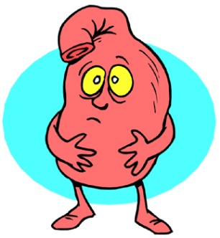Disgusting Digestion *(Adapted from:* [*http://bit.ly/2k22pJ5*](http://bit.ly/2k22pJ5) *)*

Ingredients:

* Bread
* Water
* Vinegar
* Paper Towel

Make it:

Tear a piece of bread (your teeth chewing), add a spritz of water, (your spit), add a spritz of vinegar (your stomach’s acid). Mush it up with your hands (your stomach’s muscles mushing), put into a paper towel and roll up (your small intestine) and watch the water comes out (your food’s nutrients), squeeze the towel (your large intestine) and open to see your poop (bread & water)!

DIY Lava Lamp *(Adapted from:* [*http://bit.ly/2iLlQ7L*](http://bit.ly/2iLlQ7L) *)*

Ingredients:

* Container
* Funnel
* Water
* Vegetable oil
* Food coloring
* Alka Seltzer
* Plate or towel

Make it:

Place container on plate or towel. Using the funnel fill your container ¾ way full with vegetable oil then fill it the rest of the way with water. Add desired amount of food coloring. Add a piece of Alka Seltzer and watch the lava lamp bubble up (repeat).