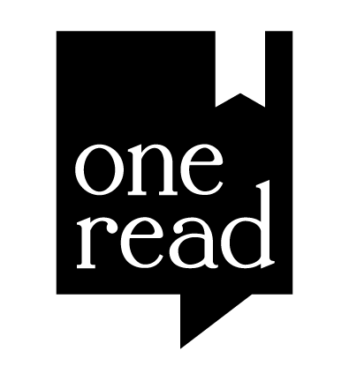
Artist name: ________________________________________________

Title of work: _______________________________________________

Medium: __________________________________________________

Address: ___________________________________________________

Phone number: ______________________________________________

email: ______________________________________________________

For sale price (optional)*: _______________________________________
*Please note that Orr Street Studios collects a commission of 35% of the sale price if your piece is purchased during this exhibit. Though we do not anticipate any problems, Orr Street Studios assumes no responsibility for artwork damaged during the course of the exhibition

Release:
Artwork sold to/
picked up by:___________________
Date: _________________
I hereby grant permission to Orr Street Studios and the Daniel Boone Regional Library (DBRL) to display the likeness of my art online (including social media platforms).

Signature: ____________________________________ Date: ____________

- - - - - - - - - - - - - - - - - - - - - - - - - - - - - - - - - - - - - - - - - - - - - - - - - - - - - - - - - - - - - - - - - - - - - - - - - - - - - - - -

Important dates:

Saturday, September 16 noon - 4 p.m.: pick up artwork not sold

Exhibition dates: September 1 – September 15
Reception and awards in person at the September 1 First Friday event.

